1. Return the first name, last name and city of all customers who live in Canada. Order the results first by the last then by the first name.

**Answer:**

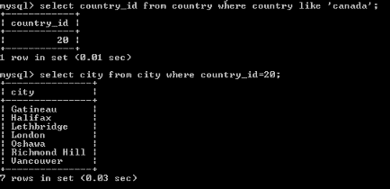

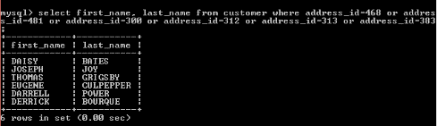

1. How many customers are from Brazil?

**Answer**

1. Return the "popular countries"? (that is, the ones with more than 20 customer). For each such country, return its name and its correspond number of customers. Order the result by the number of customers (descending)

**Answer**